Electronic Companion of Real-Time Economic Dispatch for Integrated Electric and Gas Systems Considering Pipeline Leakage Failure

Peiyao Zhao, *Student Member, IEEE*; Zhengshuo Li, *Senior Member, IEEE*; Jiahui Zhang; Xiang Bai; Jia Su

## A. Partial Differential Equations

For a single pipeline, the dynamic changes in states, including the pressure  and mass flow , can be described by the following partial differential equations (PDEs):



To facilitate the subsequent optimization procedure, the PDEs in are discretized in space and time with the central difference method. The spatial and temporal discretization of a single pipe are shown in Fig. 1.

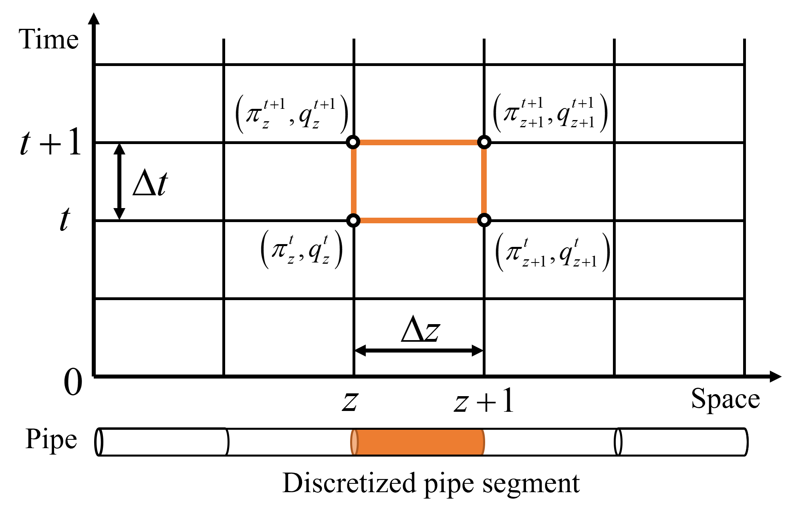

1. Central difference method

## B. Average Flow Velocity Method

We introduce the average flow velocity (AFV) method, which is adopted for the linearization of the PDEs in .

According to the gas equations of the state and mass flow, defined as:



The nonlinear term in PDEs can be approximated as:



where  denotes the AFV of the gas flow in pipe segment *z* during period *t*, which can be calculated by the following equation:



where  and  denote the flow velocities at discrete nodes *z*+1 and *z* on both sides of pipe segment *z*. Substituting into , the AFV can be rewritten as:



Thus, the PDEs can be discretized with the central difference method and further linearized with the AFV:



## C. Detailed Solution Process of the PC&CG Algorithm

The master problem is the deterministic linear optimization problem shown in and the parallel subproblems are minimax optimizations with uncertainty variables, as shown in , which can be converted into the the mixed integer linear programming model by adopting strong duality and big-M linearization, as shown in .





The detailed solution process of the PC&CG algorithm is provided in TABLE I.



Customized PC&CG algorithm for the LCBDAR evaluation subproblem

|  |  |
| --- | --- |
| **Algorithm 1 Parallel Column and Constraint Generation Algorithm** | |
| **1:** | **Initialization:** Number of iterations . Tolerance of iteration convergence . Initial enumerated scenario  or . |
| **2:** | **for** **do** |
| **3:** | **Solve** the master problem ; obtain . |
| **4:** | **Solve** subproblems **in parallel**; obtain worst-case and the optimal objective  under each pipeline leakage condition*.*    where  denote the dual auxiliary variables. |
| **5:** | For each pipeline leakage condition, generate a new adaptive decision  and add the following new constraints to the master problem . |
| **6:** | **Update** |
| **7:** | **end if** |
| **8:** | **Output** the final upper and lower bounds  of the LCBDAR. |

## D. Detailed Parameters of the Systems in Case Studies

## 1) E22-N10 system

Parameters of the pipeline network

|  |  |  |  |  |  |
| --- | --- | --- | --- | --- | --- |
| Pipe | Form node | To node | Friction coefficient | Lengths (m) | Diameter (m) |
| 1 | 1 | 2 | 0.01 | 10000 | 1 |
| 2 | 2 | 3 | 0.01 | 25000 | 0.7 |
| 3 | 2 | 4 | 0.01 | 10000 | 0.7 |
| 4 | 4 | 5 | 0.02 | 20000 | 0.7 |
| 5 | 5 | 6 | 0.02 | 20000 | 0.7 |
| 6 | 6 | 7 | 0.02 | 20000 | 0.7 |
| 7 | 4 | 8 | 0.01 | 15000 | 0.7 |
| 8 | 8 | 9 | 0.02 | 25000 | 0.7 |
| 9 | 8 | 10 | 0.02 | 25000 | 0.7 |

Parameters of the units

|  |  |  |  |
| --- | --- | --- | --- |
| Unit1 | Bus | Max output (MW) | Generation price ($/MWh) |
| C1 | 10 | 200 | 4800 |
| C2 | 17 | 200 | 5400 |
| C3 | 19 | 200 | 6000 |
| C4 | 4 | 200 | 6600 |
| G1 | 16 | 1000 | 1800 |
| G2 | 13 | 1000 | 2400 |
| G3 | 18 | 1000 | 3000 |
| G4 | 15 | 1000 | 3600 |

1:C1-C4 denote the thermal power units, and G1-G4 denote the GFUs.

## 2) E39-N20 system

Parameters of the pipeline network

|  |  |  |  |  |  |
| --- | --- | --- | --- | --- | --- |
| Pipe | Form node | To node | Friction coefficient | Lengths (m) | Diameter (m) |
| 1 | 1 | 2 | 0.01 | 10126 | 1 |
| 2 | 2 | 3 | 0.01 | 10061 | 1 |
| 3 | 3 | 4 | 0.01 | 9928 | 1 |
| 4 | 4 | 5 | 0.05 | 10102 | 0.7 |
| 5 | 5 | 6 | 0.05 | 10120 | 0.7 |
| 6 | 6 | 7 | 0.05 | 10066 | 0.7 |
| 7 | 4 | 8 | 0.02 | 10083 | 0.8 |
| 8 | 8 | 9 | 0.02 | 10080 | 0.8 |
| 9 | 9 | 10 | 0.02 | 10004 | 0.8 |
| 10 | 10 | 11 | 0.02 | 10061 | 0.8 |
| 11 | 11 | 12 | 0.02 | 9957 | 0.7 |
| 12 | 12 | 13 | 0.02 | 10072 | 0.7 |
| 13 | 13 | 14 | 0.02 | 9927 | 0.7 |
| 14 | 14 | 15 | 0.02 | 9980 | 0.7 |
| 15 | 11 | 16 | 0.02 | 9930 | 0.7 |
| 16 | 16 | 17 | 0.02 | 9941 | 0.7 |
| 17 | 17 | 18 | 0.02 | 10097 | 0.7 |
| 18 | 8 | 19 | 0.02 | 10069 | 0.7 |
| 19 | 19 | 20 | 0.02 | 9988 | 0.7 |

Parameters of the units

|  |  |  |  |
| --- | --- | --- | --- |
| Unit1 | Bus | Max output (MW) | Generation price ($/MWh) |
| C1 | 30 | 200 | 4800 |
| C2 | 37 | 200 | 5040 |
| C3 | 38 | 200 | 5280 |
| C4 | 39 | 200 | 5520 |
| C5 | 36 | 200 | 2160 |
| G1 | 31 | 1000 | 2400 |
| G2 | 32 | 1000 | 2880 |
| G3 | 33 | 1000 | 3360 |
| G4 | 34 | 1000 | 3840 |
| G5 | 35 | 1000 | 4320 |

1:C1-C5 denote the thermal power units, and G1-G5 denote the GFUs.